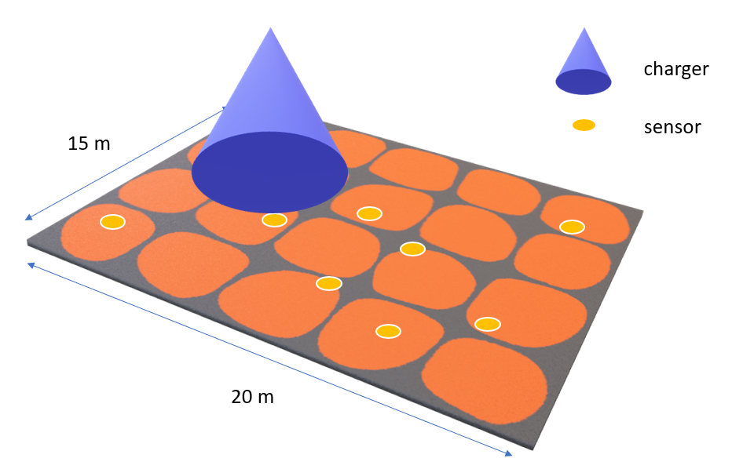

Figure 3. 20 x 15 indoor environment